2.

a.

**DC Values**

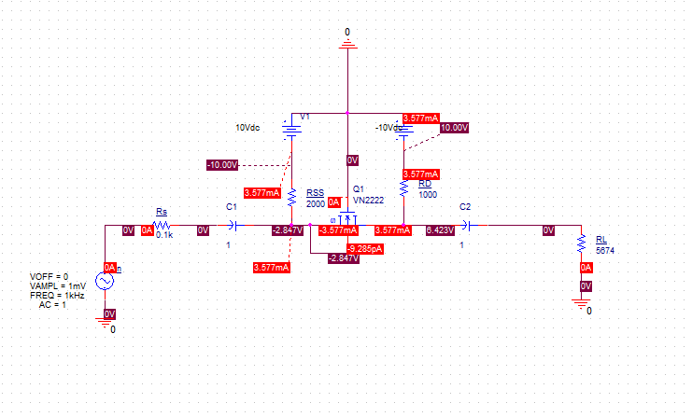

b.

**Simulated DC Bias Parameters**

|  |  |
| --- | --- |
| DC Bias Parameters | |
| IDQ | 3.577mA |
| VGSQ | 2.847V |
| VDSQ | 6.423V |
| PD | 33.2mW |

$$For transistor on:V_{GS}≥ V_{TN}$$

$$2.847V ≥2.6V So transistor is on$$

$$For Saturated Region, V_{DS}≥ V_{DS SAT}= V_{GS}-V_{TN}$$

$$6.423V ≥\left(2.847V-2.6V\right)= 6.423V ≥ 0.247V So transistor is saturated$$

$${To not exceed\max{power rating= }P}_{D}≤ P_{DMax}$$

$$33.2mW≤ 500mW so\max{power rating is not exceeded}$$

c.

**Simulated Gain**



Vout peak is 6.2070mV

Vin peak = 0.9991mV

$A= \frac{V_{out}}{V_{in}}=\frac{6.0270mV}{0.9991mV}=6.213V/Vwith minimal distortion$

d.

**Simulated Input Resistance**

$R_{in}= \frac{Vin}{Iin}= \frac{0.9991mV}{7.4119μA}=133.704Ω$

The calculated value was 100Ω. This is a 25% deviation from the actual value.

**Simulated Input Current**



The simulated input current is 7.4119µA.

**Simulated Input Voltage**



The simulated input voltage is 0.9991mV.

e.

**Simulated Output Resistance**

$R_{in}= \frac{Vout}{Iout}= \frac{6.2070mV}{1.0914μA}=5687.191Ω$

The calculated value was 5674Ω. This is a 0.23% deviation from the actual value.

**Simulated Output Voltage**



The simulated output voltage is 6.2070mV.

**Simulated Output Current**



The simulated output current is 1.0914µA.

f.

**Simulated Gain Over Temperature**



At 85°C

Vout peak is 6.4846mV

Vin peak = 0.9991mV

$A= \frac{V_{out}}{V_{in}}=\frac{6.4846mV}{0.9991mV}6.490 V/V$ This is a 4% deviation from the original gain.

At 25°C

Vout peak is 6.2010mV

Vin peak = 0.9991mV

$A= \frac{V_{out}}{V_{in}}=\frac{6.4846mV}{0.9991mV}6.206 V/V$ This is a 0.11% deviation from the original gain.

At -40°C

Vout peak is 5.9734mV

Vin peak = 0.9991mV

$A= \frac{V_{out}}{V_{in}}=\frac{5.9734mV}{0.9991mV}=5.979 V/V$ This is a 4% deviation from the original gain.

With a max 4% deviation from the original gain, the gain can be considered stable under changing temperature.